**Abstract:** Nowadays the road accidents in modern urban areas are increased to uncertain level. The loss of human life due to accident is to be avoided. Traffic congestion and tidal flow are major facts that cause delay to ambulance. To bar loss of human life due to accidents we introduce a scheme called ITLS (Intelligent Traffic Light system). The main theme behind this scheme is to provide a smooth flow for the emergency vehicles like ambulance to reach the hospitals in time and thus minimizing the delay caused by traffic congestion. The idea behind this scheme is to implement ITLS which would control mechanically the traffic lights in the path of the ambulance. The ambulance is controlled by the control unit which furnishes adequate route to the ambulance and also controls the traffic light according to the ambulance location and thus reaching the hospital safely. The controller identifies the location of the accident spot through the sensor systems in the vehicle which determined the accident and thus the controller walks through the ambulance to the spot. This scheme is fully automated, thus it finds the accident spot, controls the traffic lights, help ingtoreach the hospital in time.

1. **INTRODUCTION**

Nowadays Wireless device Networks (WSN) has been applied in varied domains like weather observation, military, home automation, health care observation, security and safety etc. Traffic light System or traffic observation could be a huge domain wherever WSN may be applied to collect information regarding the incoming flow of traffic, traffic load on a specific road, traffic load is clear and in vehicles can. WSN put in on a road may be used to manage the traffic load on roads and at traffic intersections.

The device nodes that are to be deployed on the road are tiny in size and have low energy consumption. These sensors run on each battery power also as alternative energy. They need the potential to draw alternative energy in order that they will use daylight for functioning in bright and sunny condition and therefore the battery power for engaging at night or in cloudy or foggy condition. Devices utilized in the Wireless Sensor Network for traffic light systems are chiefly of 2 kinds: i) Intrusive kind and ii) NonIntrusive type. ii) Intrusive sorts of device are unbroken below the road and sense the traffic waiting at the signal. This kind of device has a similar rule as that of a sensor. ii) Non-Intrusive sorts of device is fitted on the road. The installation of this kind of device is simple as no cutting of road is required to be done. Non-intrusive device includes acoustic sensors or video image processors to notice the presence of vehicles waiting at the traffic intersection. Though Intrusive sensors are terribly effective still Nonintrusive sensors are most popular over Intrusive sensors as they're efficient, straightforward to put in, resistant to natural corrosion and degradation

1. **PROPOSED SYSTEM**

In proposed system, if a car has met injuries, straight away an alert message with the place coordinates is dispatched to the control center. From the manage middle, a message is dispatched to the nearby ambulance. Also signal is transmitted to all the alerts in between ambulance and car area to offer RF communication among ambulance and site visitors segment. The vehicle twist of fate observed the use of vibration sensor and inside the control segment it is obtained through the microcontroller and then the close by ambulance is received from the pc and controller sends the message to the ambulance. The sign to visitors signal segment is transmitted through RF verbal exchange. Additionally if any fire happens, it is miles detected the usage of hearth sensor and an alarm message is without delay sent to the fire station.

II**. BLOCK DIAGRAMS**

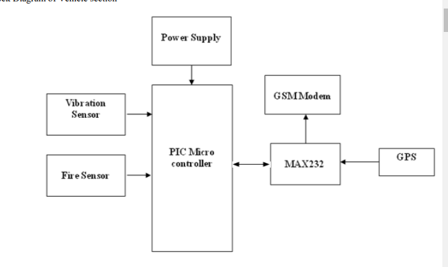

If a automobile has met accident, vibration sensor or fire sensor offers the electric signal to microcontroller through signal conditioner. Then GPS provides range and longitude facts about vehicle place to govern phase through GSM.

In control section GSM modem receives message about accident and send it back to Picmicrocontroller. Picmicrocontroller identifies the nearest ambulance and ambulance is collected or to pick up the patient. Control section transmits the control signal to all the signals in between ambulance and vehicle by RF transmission.

Whenever the ambulance reaches near to the traffic signal(approximately 100m), the traffic signal will be made to green through RF Communication. Then the vehicle drivers may know that someone one has serious, therefore all vehicles may give side to ambulance. There by the ambulance is recommended to reach the hospital in time.

1. **SYSTEM IMPLEMENTATION**

Our system consists of three main sections, which coordinates with each other and makes sure that ambulance reaches the hospital without any time delay. Then the system is divided into following three sections

• The Vehicle section

• The Ambulance/control section

• Traffic section

1. **Vehicle Section:**

The controller may send the signals to the closest ambulance to the coincidence spot and also the shortest route between the ambulance, accident spot and the nearest hospital to save them. The controller then sends this path to the ambulance. Also the usage of these facts the controller controls all of the traffic signals inside the course of ambulance and makes it prepared to provide unfastened path to ambulance, which guarantees that the ambulance reaches the hospital straight away. On the same time, the ambulance section activates the RF transmitter. This can cause speak with the traffic section.

1. **Ambulance or Control Section**

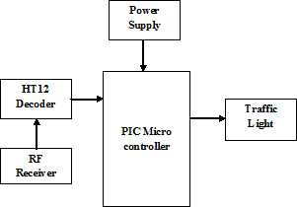The controller finds the closest ambulance to the coincidence spot and additionally the shortest path between the ambulance, accident spot and the nearest medical hospital. The controller then sends this route to the ambulance. Additionally the use of this statistics the controller controls all the traffic indicators in the route of ambulance and makes it equipped to provide loose course to ambulance, which guarantees that the ambulance reaches the sanatorium at once. On the same time, the ambulance section activates the RF transmitter. This may cause talk with the traffic section.

1. **Traffic Section:**

On every time ambulance signal segment receives the information about twist of fate, the RF receiver receives the signal from ambulance is grew to become on to probe for ambulance nearing the traffic signal. Every time the ambulance reaches proximate to the traffic signal (approximately 100m), the traffic signal may be made to unseasoned via RF conversation.

**Block Diagram of Ambulance/Control section**

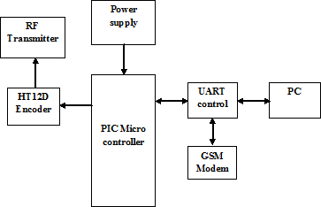

**Block Diagram of Traffic Section**

# SIMULATIONRESULTS

**Accident Condition**

If a car has met an accident, the vibration sensor gives thesignal to pic microcontroller through sign conditioner. Then the GPS affords latitude and longitude statistics about vehicle area to govern phase through GSM

**Before Ambulance Reaching Traffic Signal**

Before ambulance reaching the traffic signal junction,the Signal will bered.Control section transmits the controlsignal to all the signals in between ambulance and vehicle by RF transmission.

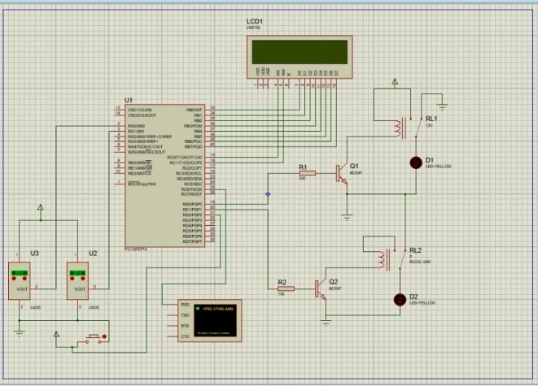

**After Ambulance Reaching Traffic Signal**

After ambulance reaching the traffic signal junction,the signal will turn in to green with the help of the RF signal transmission.

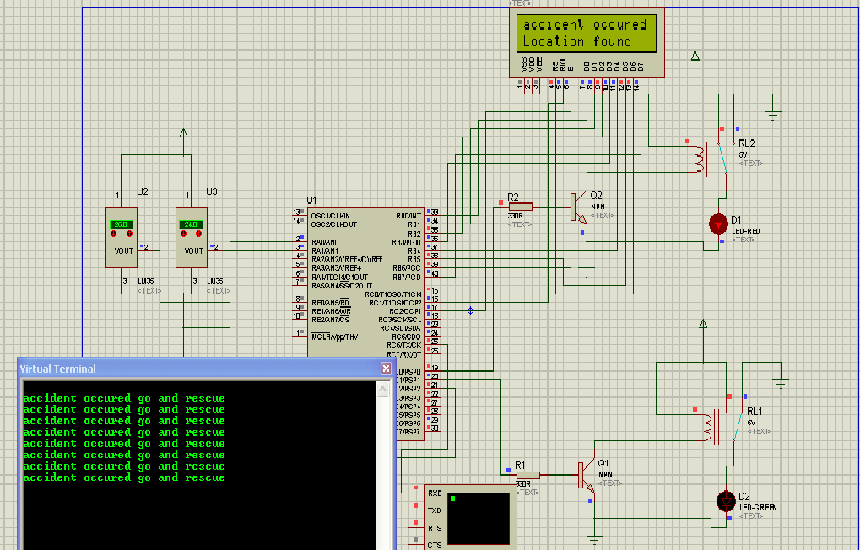

**Conclusion**

In this paper,I proposed for controlling the traffic signals in chooses of ambulances all through the accidents and with this gadget ambulance can be maneuvered from the ITLS may be proved to be effective to control now not handiest ambulance and also other vehicles.For this reason ITLS if carried out in countries with massive population like India can produce higher effects.The ITLS is extra accurate without a loss of time.However there may be a postpone prompted due to GSM message when you consider that it’s miles a queue primarily based method which can be decreased via giving greater priority to the messages communicated through the traffic controller.

RESOURSE PERSON

J.Surya

R.Vasanth vel

2nd year ,ECE Depertment

P.A.College of Engineering And Technology